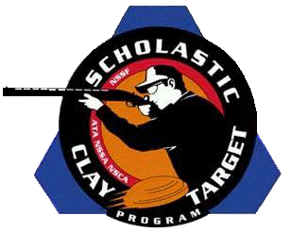

JODC & SPORTING CLAYS COACH CAMP APPLICATION
2023 Shooting Season
Scholastic Clay Target Program (SCTP)
925 Milwaukee Ave STE B1 Burlington, WI 53105 (262) 939-6664
tom@mysctp.com

Camp Interested In: (select one) May 2023

Current Position: Head Coach Assistant Coach State Advisor

Shooting Disciplines: American Trap American Skeet Sporting Clays

Intl. Skeet Intl. Bunker Trap

Team Name:

Years with SCTP:

I Would Like To Learn: American Skeet Intl. Bunker Trap Sporting Clays

Coaching Goals & Objectives?

What would you expect to learn from this coach’s class?

Describe your background in coaching & shooting.

Are you able to pay the $950 fee for class materials, meals, targets & ammo? Yes No

*Due to scheduling & commitments, there will be no refunds of fees 21 days or less before the event takes place.

Coach Name: (Print Please) State:

Signature: E-Mail Address:

Send Forms To: SCTP/May Camp || 925 Milwaukee Ave STE B1 || Burlington, WI 53105 || 262.939.6664

